A survey of 500 Defendants about Restorative Justice: Their Awareness of and Interest in participating in Restorative Justice
Gretchen Casey
Gainesville, Florida
June 2019
Abstract
This 2018 study examines defendant awareness about restorative justice and defendant interest in participating in restorative conversations with victims of their crimes. Using a non probability convenience sample of individuals sentenced to prison and individuals serving probation, 500 individuals who identified as defendants in criminal cases were asked to complete a 4 question survey about their awareness of Restorative Justice (RJ) and their personal interest in participating in RJ if it was available in their criminal case. The results of the survey are shared publicly in the hopes it will inspire further study by researchers within both academic and prison institutions. Our hope is that this survey will bring increased attention to the needs of victims and the accountability that restorative justice and the Florida criminal justice system can invite, support, and offer to offenders as a means to repair and prevent reoccurring harm. This study was funded by the River Phoenix Center for Peacebuilding (RPCP) and conducted in 2018 and authored by Gretchen Casey, RPCP Director of Restorative Justice Outreach and Training.

Introduction
In the past 20 years, utilization of Restorative Justice has expanded in the United States as community members and elected officials focus on criminal justice reform and the needs of victims and offenders. Restorative justice has been conceptually defined as the theory and practice of interested stakeholders coming together to discuss, address, and repair the harm that has occurred in the wake of a conflict. The impact of a conflict arising out of criminal act can involve a wide range of losses, emotional turmoil, and the deprivation of human relationships. Restorative practices are an opportunity for dialogue between people: people who have been harmed by crime and people who have an opportunity to listen to the impact and demonstrate accountability. Restorative justice accomplishes this by inviting facilitated face-to-face communication focused on the harm resulting from a conflict and the desire to repair and address the needs that are expressed by participants. The facilitated meetings are safe and mutually beneficial and supportive for those harmed by conflict: victims, offenders, families, and communities.
In 2018, RJ was not a statewide option available to adult defendants or inmates in Florida. The availability to participate in RJ in a prison setting or during probation varies widely across states and jurisdictions in the United States. (See Maps below)
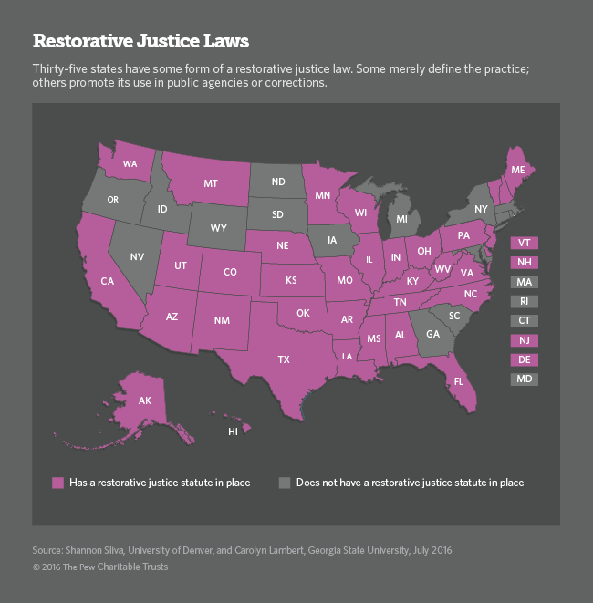

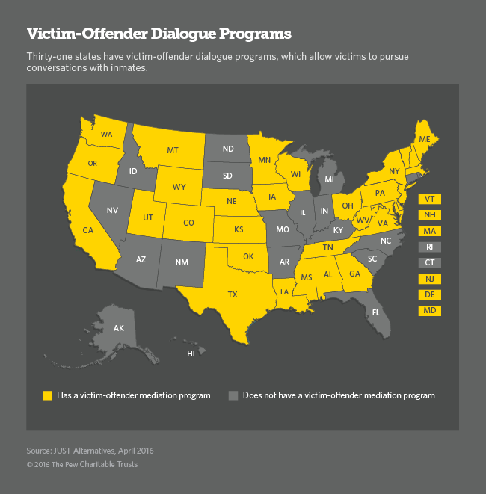
The Restorative Justice Awareness and Interest Survey
The data presented is derived from a survey of 500 people of which males comprised approximately 70% of the respondents. Approximately 80% of the surveys were completed by individuals incarcerated in prisons and 20% of the respondents were on probation for a criminal act. The survey asked respondents to answer 4 questions about their awareness of and interest in participating in a restorative justice process with a victim. A copy of the survey is provided below.

This survey is voluntary and does not ask you to identify yourself.
You are not required to participate or complete this survey. Your participation in this survey will NOT have any impact on the outcome of your criminal case.

- Have you ever heard of a Restorative Justice Circle? Yes No

2. A restorative justice circle is a free, voluntary meeting between the victim and a person accused of wrongdoing. Both victim and the accused meet with a trained facilitator and have an opportunity to 1) describe what happened and the impact of the incident on their lives, and 2) are invited to listen, acknowledge, and repair the harm. The meeting typically lasts 2 hours. Four primary questions are discussed: 1. Describe what happened from your perspective; 2. Identify the impact and harm from the incident on each person, and others; 3. Come up with ideas of how to address the harm and impact to make things better; and 4. Discuss solutions to prevent the incident from happening again.

IF a free, safe, restorative Justice circle was available to you in your case would you choose to participate in it?
No Yes Maybe

3. If you are a person identified as the defendant or suspect in a criminal case what is the Charge/Type of Criminal offense: _______________________________

4. Please circle the description that describes the relationship between you and the victim in the case:
Family member or relative Neighbor Friend Recent acquaintance
Partner or person you were dating or living with Known through work or school
Stranger/person(s) not known to me Drug case or there is NO victim in my case Other:

Thank you for answering each question.
Findings
Tables 1- 5 present descriptive statistics of the survey responses. The data does not demonstrate causation between variables. However, there is a noteworthy relationship between the interest in participating in RJ as it relates to the defendant’s relationship to victim and the type of crime committed. Due to the variety of answers provided for question 3 regarding the relationship between the defendant and the victim, the “Acquaintance” category includes neighbor, friend, recent acquaintance, roommate or person you were or had been living with, or a person known through work or school.
Key findings:
- Survey respondents reported involvement in 121 death cases (murder of any degree, manslaughter, DUI resulting in death), 31 sexual crimes, 126 property crimes, 84 personal crimes not resulting in death, 75 drug crimes, and 44 other crime categories (includes multiple offense categories)
- Thirty percent of all respondents surveyed (n=152) said that they had heard of restorative justice and 69% (n=345) said they had not heard of restorative justice.
- Upon being provided a description of what Restorative justice is and what it involves, 338 respondents (67.6%) said they would participate and 98 (19.6%) answered Maybe/unsure. Only 56 (11%) stated that they would not choose to participate in a RJ meeting.
- Of those people who reported they had heard of RJ almost 80% (n=121) said they would choose to participate in an RJ meeting.
- When considering the type of crime, the highest percentage of respondents who indicated they would participate in a restorative justice meeting occurred when the stated offense was a sexual crime (80.6%, n=25) or a crime resulting in Death (79%, n=96)
- Of respondents who indicated they would participate in a restorative justice meeting the highest percentage was when the stated relationship involved a family member (75.5%, n=65) Stranger (70.5 %, n=122) or Acquaintance (68.6 %, n=81)
- Of the 69% of respondents surveyed (n=345) that had not heard of restorative justice, 62% (n=215) reported they would choose to participate in RJ, 22% (n=77) said maybe or unsure, and only 14% (n=48) said they would not choose to participate in a RJ meeting with the victim.
- Of the 56 total respondents who indicated they would not participate in restorative justice practices the stated crime involved a property crime (n=20) or drug crime (n=13)
Table 1: Q1 Have you ever heard of Restorative Justice?
Q1 Answer: | Frequency (#) | Percentage
Yes | 152 | 30.4%
No | 345 | 69%
Note: 3 respondents did not answer Q1.

Table 2: Q2 After reviewing a description of restorative justice, if a free, safe, restorative Justice circle was available to you in your case would you choose to participate in it?

Q2 Answer: | Frequency | Percentage
Yes | 338 | 67.6%
Maybe/Unsure | 98 | 19.6%
No | 56 | 11.2%
Not answered | 8 | 1.6%
Total | 500 | 100%

Table 3: Cross-tabulation of Q1 Heard of RJ and Q2 interest in participation
 | Q2 If a free, safe, restorative Justice circle was available to you in your case would you choose to participate in it?
 | Yes  n=338 | Maybe/Unsure  n=98 | No  n=56 | Not answered  n=8
Heard of RJ?
Yes n = 152  30.4% | n=121  79.6% | n=21  13.8% | n=8  5% | n=2
No n= 345  69% | n=215  62% | n=77  22% | n=48  14% | n=5
Not answered  n=3 | n=2 | n=0 | n=0 | n=1
Total n= 500 | n=338  67.6% | n=98  19.6% | n=56  11.2% | n=8  1.6%

Table 4: Cross-tabulation of willingness to participate in RJ and type of Crime
Q2: Would you Participate in RJ? |  | Type of Crime:
 |  | Death | Sexual Crime | Property | Personal | Drug | Other | Not  Answered | Total
 | Yes #  % | 96  (79%) | 25  (80.6%) | 76  (60%) | 60  (71%) | 42  (56%) | 27  (61%) | 12  (63%) | 338 (67.6%)
 | Maybe or #  Unsure % | 23  (19%) | 4  (13%) | 27  (21%) | 16  (19%) | 19  (25%) | 9 | 0 | 98 (19.6%)
 | No #  % | 1 | 2 | 20  (15.8%) | 8  (10%) | 13  (17%) | 7  (16%) | 5 | 56 (11.2%)
 | Not Answered | 1 | 0 | 3 | 0 | 1 | 1 | 2 | 8  (1.6%)
Total |  | 121 | 31 | 126 | 84 | 75 | 44 | 19 | 500
Key: Death involves any crime that resulted in death including all forms of murder, DUI manslaughter, Leaving the scene of a crash with a fatality, Sexual Crime includes adult or child sexual battery, lewd and lascivious acts, pornography charges. Property includes any crime resulting in property damage, burglary, theft, arson, DUI without Personal: any assault or battery charge involving physical harm or an attempt to harm, that did not result in death Drug included any charge of possession, distribution or sale of an illegal drug Other includes DUI without injury or damage, multiple categories of crimes listed, fleeing, Probation violation, DWSL, Accessory after the fact

Table 5: Cross-tabulation of willingness to participate in RJ and Relationship to Victim
Q2: Would you Participate in RJ? | Relationship of Def/Victim:
 | Stranger | Acquaintance | Family | No Victim | Not answered | Other
Yes 338 (67.6%) | 122  (70.5%) | 81  (68.6%) | 65  (75.5%) | 32  (58%) | 11  (38%) | 27  (69%)
Maybe/Unsure  98 (19.6%) | 37  (21%) | 22  (18.6%) | 12  (14%) | 14  (25%) | 4  (13.7%) | 9  (23%)
No  56 (11.2%) | 13  (2.6%) | 14  (2.8%) | 7  (1.4%) | 9  (1.8%) | 10  (2%) | 3  (.6%)
Not Answered 8 (1.6%) | 1 | 1 | 2 | 0 | 4 | 0
Total 500  100% | 173  34.6% | 118  23.6% | 86  17.2% | 55  11% | 29  5.8% | 39  7.8%

Acknowledgements:
The author wishes to express her sincere appreciation to the individuals who contributed to this publication. I was fortunate to have my friend and colleague Laila Fakhoury provide me with the opportunity to speak with and survey incarcerated individuals at the men’s and women’s Marion County (Florida) Correctional institutions. Laila also assisted me at many stages of collecting, entering and recoding the survey responses into a database.
I am also grateful to Jhody Polk for introducing me to Sierra Williams, an African American woman who works as Birth Educator and Doula for Minnesota Prison Doula Project. Sierra collected 8 RJ surveys from women at Ramsey County Correctional Facility in Minnesota. Sierra works inside Ramsey County Correctional facility and if a woman goes into labor while incarcerated she supports them during their labor process. She makes sure their rights are not violated and gives them care to assure the children have their rights to a positive introduction into life, just as everyone else in life deserves.

I could not have analyzed the data using SPSS without the help and oversight of Dr. Nicole Stedman, Professor and Associate Department Chair in Agricultural Education and Communication at the University of Florida.
I am grateful to Heart Phoenix and Jeffrey Weisberg of the River Phoenix Center for Peacebuilding for underwriting the cost and supporting my time to complete this project. Community funded programs that collect, analyze and share data play an important role in informing public policy. One of the most powerful ways to grow understanding of and for those most impacted by criminal acts is to generate conversations around this critical issue.
Lastly, I would like to express my sincere and enduring appreciation to each person whose responses provided the substance of this report. I am indebted to the 500 men and women who are incarcerated or on probation and who agreed to participate in the survey. Your voices and choices matter. May this report inspire additional research and guide criminal justice policy regarding the availability of restorative justice in adult criminal cases.

~~~~~~~~~~~~~~~~~~

Declaration of Conflicting Interests
The author declares no potential conflicts of interest with respect to the research, authorship, and/or publication of this article.
Funding
The author received no financial support for the research, authorship, and/or publication of this article.

